**STEP FOR CREATE 1) SERVER KEY-and 2) google-service.json file**

**Step No. 1 : Go to FCM developer console :**

-> https://console.firebase.google.com/

**Step No. 2 : Create New Project**

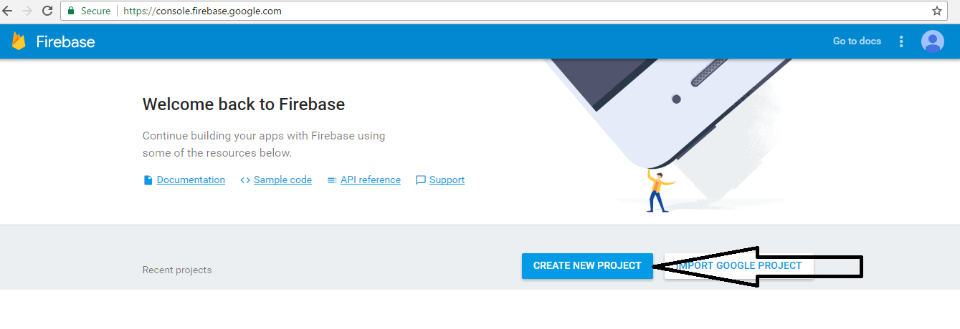

**Step No. 3 : Add Project name and country**

Add project name and country as above and then click on Create project tab.

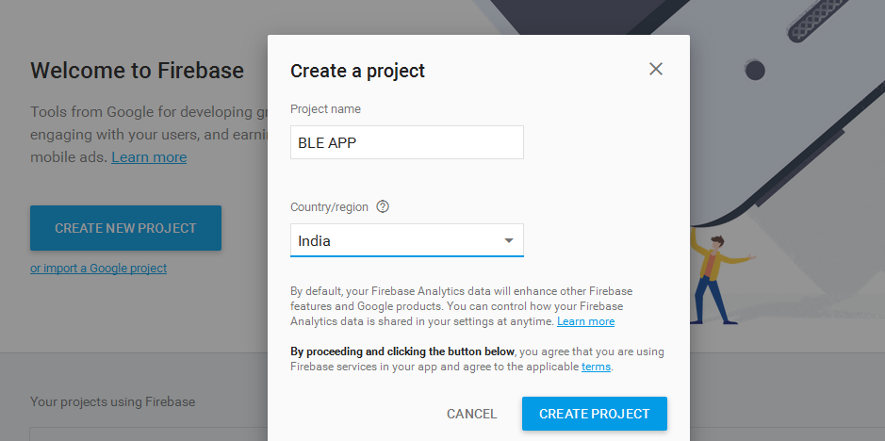

**Step No. 4 : Add firebase to your android app**

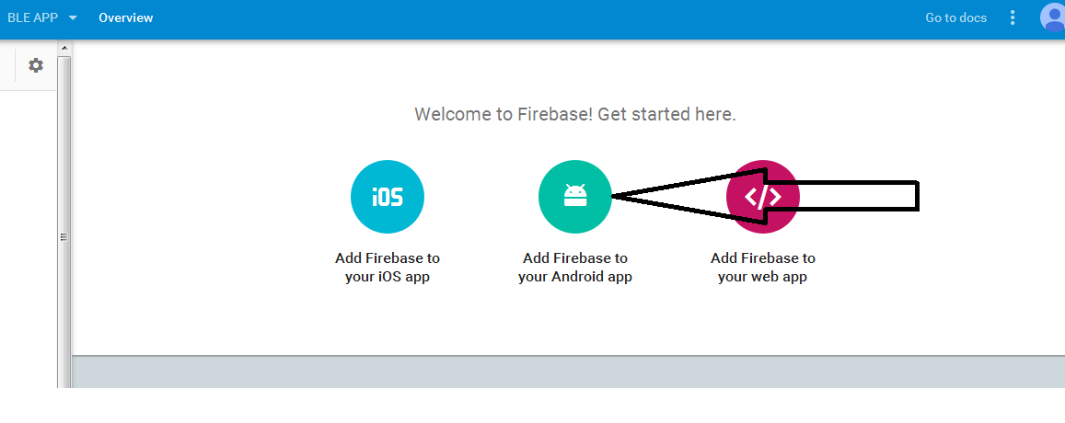

Click on add firebase to your android app as below and then it will open one popup.

Add all details as below:

Package Name: com.bleservices

SHA-1 Key: E9:67:F0:05:8D:75:47:76:FC:46:B4:D3:8B:CA:10:AC:89:64:D2:E1

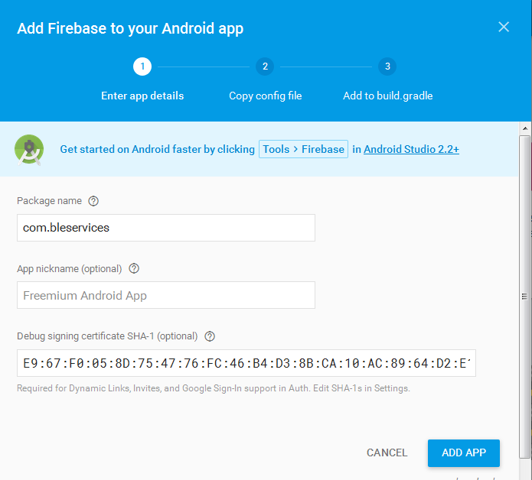

After adding application package name and sha-1 key Click on add app tab.

**Step No. 5 : Copy config file**

After Click on add app, you move on step-2 copy config file in that you have to download google-service.json file.

Please provide that "google-service.json" file to us.

After that click on continue tab and then finish tab.

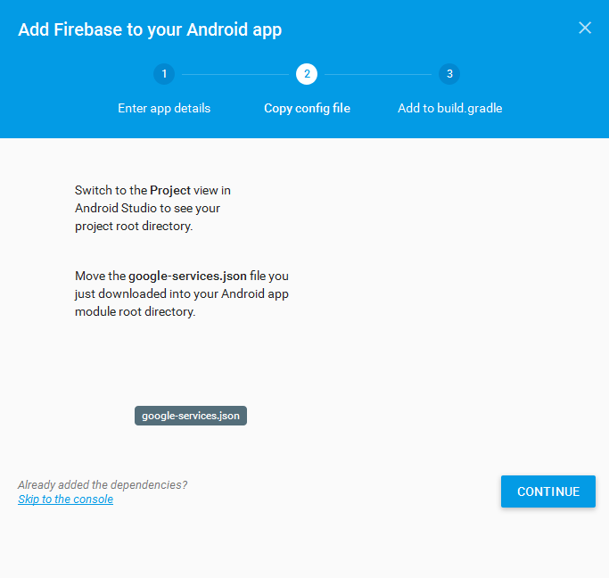

You also download google-service.json file later after all step from the following way:

Click on your (BLE APP) project 🡪 Setting 🡪 and Click on goolge-service.json like following screenshot:

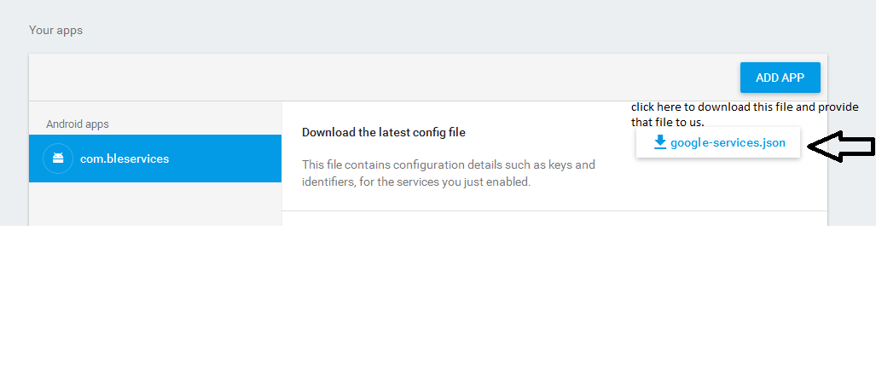

**Stpe 5 : Get server key**

Click on **Clound Messaging** tab on your created app.

You can see **legecy server key** on that. Please provide that lagecy server key to us.

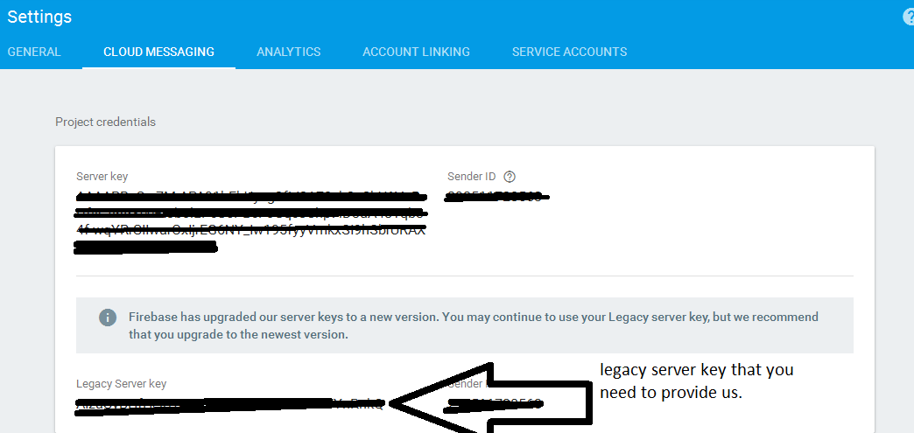

**Thank you**